AP Biology Name______________________________________

Cell Study guide Period_______

**I.** Explain the contributions of the following people to our present day understanding of the cell.

1. Anton van Leeuwenhoek___________________________________________________

2. Robert Hooke____________________________________________________________

3. Robert Brown____________________________________________________________

4. Matthias Schleiden_________________________________________________________

5. Theodore Schwann_________________________________________________________

6. Rudolf Virchow___________________________________________________________

**II**. The findings of the preceding people were used to develop the cell theory. List the three major parts of the Cell Theory.

1._________________________________________________________________________________________

2._________________________________________________________________________________________

3._________________________________________________________________________________________

**III.** What are the basic structures found in all Prokaryotic Cells?

1. _______________________________________________________________________________________
2. _______________________________________________________________________________________
3. _______________________________________________________________________________________
4. ________________________________________________________________________________
5. ________________________________________________________________________________

**IV**. What are the difference between Prokaryotes and Eukaryotes as discussed in class?

1. _____________________________________________________________________________________
2. _____________________________________________________________________________________
3. _____________________________________________________________________________________
4. _____________________________________________________________________________________
5. _____________________________________________________________________________________
6. _____________________________________________________________________________________

**V.** Like human's, which have organs which performs specialized functions to keep us alive, cells also have specialized parts which must perform certain jobs to maintain the cell's life. On the following cell

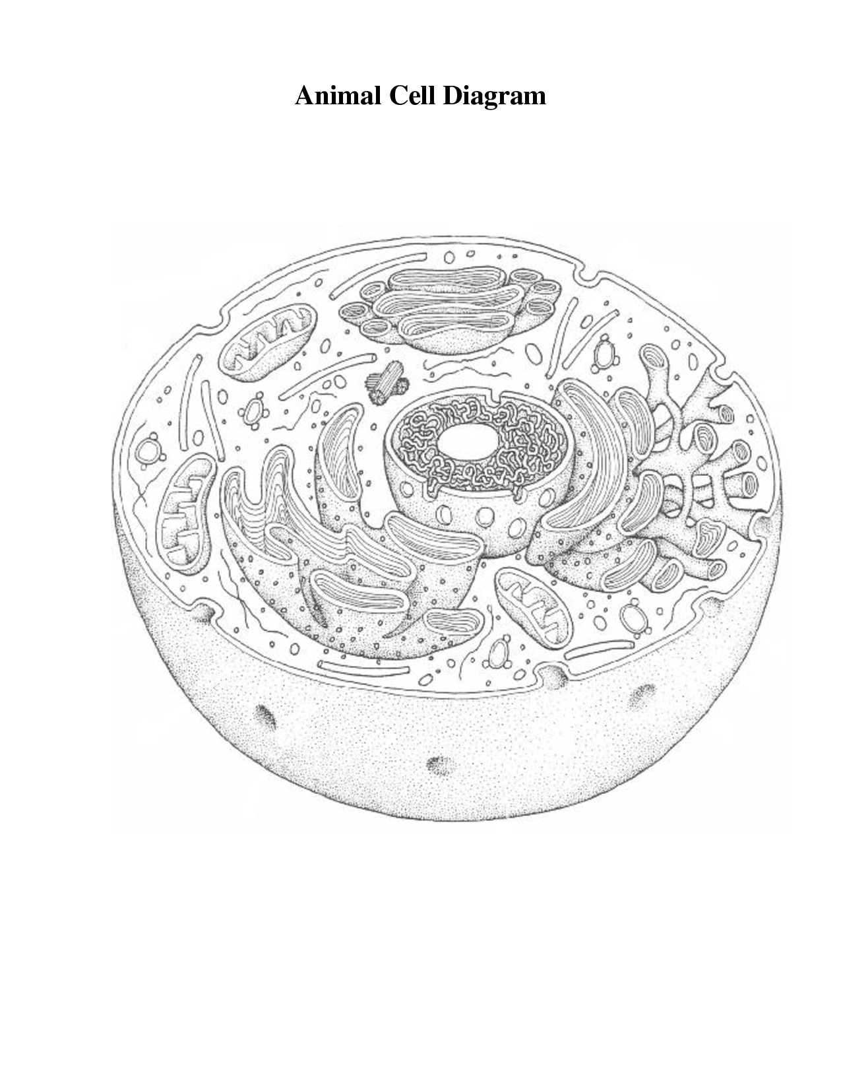 diagrams, name the cell part or organelle and write the function performed by each of these.

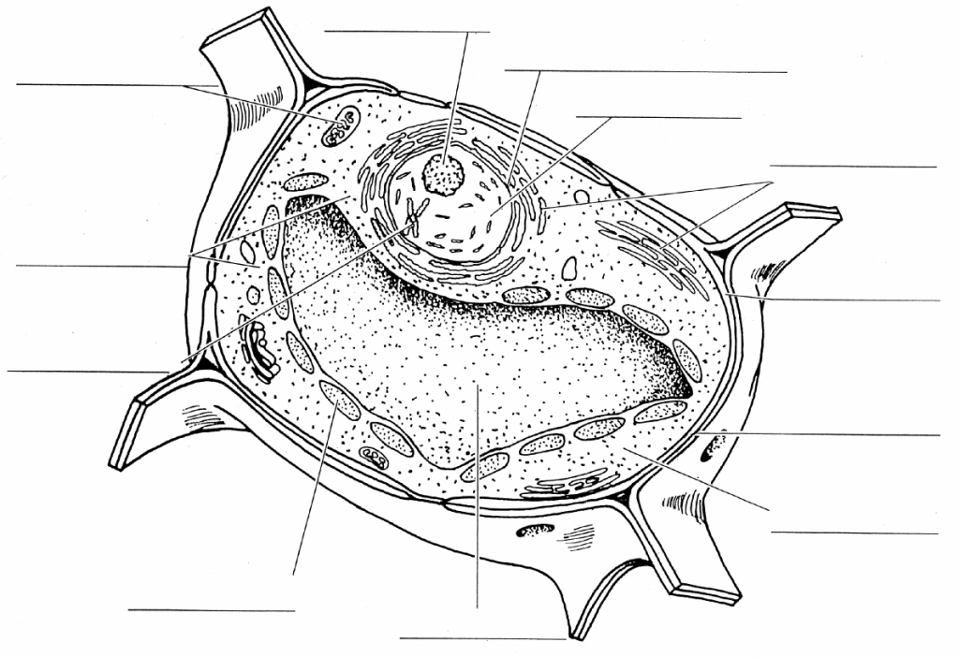 **Plant Cell Diagram**

M

P

L

J

A

N

B

G

C

D

C

J

M

L

K

B

A

N

|  |  |
| --- | --- |
| **Name**  H  I | **Function**  E  O  K  G  F |
| A. |  | |
| B. |  | |
| C. |  | |
| D. |  | |
| E. |  | |
| F. |  | |
| G. |  | |
| H. |  | |
| I. |  | |
| J. |  | |
| K. |  | |
| L. |  | |
| M. |  | |
| N. |  | |
| O. |  | |
| P. |  | |

**VI.** Which two organelles are found only in animal cells?

1. _____________________________ 2. _____________________________

Which organelles are found only in plant cells?

1. _____________________________ 2. _____________________________

3. _____________________________

**VII.** What size, shapes, and surface adaptations help provide a sufficiently high ratio of surface area to volume to accommodate the exchange of material across the cell membrane?

The cells of an ant and an elephant are, on average, the same size; an elephant just has more cells. Describe the advantages of small cell size compared to a large cell size?

Explain what cytoplasm is. Is it the same as cytosol?

Explain the basic structure, functions, and how lysosomes are manufactured.

Explain what the nucleolus is and what it does.

Write the functions of each of the following plant cell structures

Cell wall

Central vacuole

Chloroplast

Amyloplast

Plasmodesmata

Write the organelles and structures associated with the following functions.

Cell division

Information and transferal

Energy conversions

Manufacture or proteins, membranes, and other products

Lipid synthesis, drug detoxification

Digestion, recycling

Oxidation, conversion of H2O2 to water

Structural integrity

Movement

Exchange with the environment

Cell to cell connections

Explain the difference between chromatin and chromosomes.

Explain what makes up the endomembrane system and what it does.

Give the main functions of smooth ER.

Give the main function of rough ER.

Explain what the cytoskeleton is, what it is composed of, and what it does. Give a couple of specific functions of the cytoskeleton.

Explain what a plastid is and give 2 examples.

Compare and contrast thylakoid and grana and their roles in the cell.

Where are the mitochondria located in the cell and what do they do? Which cells would contain a lot of mitochondria?

Where are the chloroplasts located in the cell and what do they do? Which cells would contain a lot of chloroplasts?

Contrast the functions of the cis and trans sides of the Golgi apparatus.

Explain what is meant by phagocytosis.

Which diseases affect lysosomes?

Explain the function and structure of the plasma membrane. Include a picture.

Explain what a vesicle is and what it does.

What do centrioles do?

Give the 3 main types of intercellular links in animals and what they do.

Explain what intermediate filaments are and what they do.

What is the basic design of the cell wall and its functions?

**IX.** Explain how the following work:

* light microscope
* electron microscope
* transmission electron microscopes
* scanning electron microscopes

The detailedstructure of a chloroplast can be best seen with the best resolution using which microscope?

What do cell biologists use a TEM to study?

What does an SEM show best?

What advantage does light microscopy have over both TEM and SEM?

What is resolution?